WEEK-5 HandsOn
CREATING MICROSERVICES FOR ACCOUNT AND LOAN

Objective
To build two Spring Boot 3.5.4 microservices:
* `account-service`: manages account data
* `loan-service`: manages loan data
Both services use Spring Data JPA with H2 in-memory databases, expose REST endpoints, and auto-load sample records.

ACCOUNT SERVICE
AccountServiceApplication.java

package com.example.accountservice;
import org.springframework.boot.CommandLineRunner;
import org.springframework.boot.SpringApplication;
import org.springframework.boot.autoconfigure.SpringBootApplication;
import org.springframework.context.annotation.Bean;
@SpringBootApplication
public class AccountServiceApplication {
public static void main(String[] args) {
SpringApplication.run(AccountServiceApplication.class, args);
}
@Bean
public CommandLineRunner loadData(AccountRepository repository) {
return args -> {
repository.save(new Account("John", 1000.0));
repository.save(new Account("Alice", 2500.0));
};
}
}

Account.java

package com.example.accountservice;
import jakarta.persistence.*;
@Entity
public class Account {
@Id
@GeneratedValue(strategy = GenerationType.IDENTITY)
private Long id;
private String name;
private Double balance;
public Account() {}
public Account(String name, Double balance) {
this.name = name;
this.balance = balance;
}
public Long getId() {
return id;
}
public String getName() {
return name;
}
public Double getBalance() {
return balance;
}
public void setId(Long id) {
this.id = id;
}
public void setName(String name) {
this.name = name;
}
public void setBalance(Double balance) {
this.balance = balance;
}
}

AccountRepository.java

package com.example.accountservice;
import org.springframework.data.jpa.repository.JpaRepository;
public interface AccountRepository extends JpaRepository<Account, Long> {}

AccountController.java

package com.example.accountservice;
import org.springframework.web.bind.annotation.*;
import java.util.Optional;
@RestController
@RequestMapping("/api/accounts")
public class AccountController {
private final AccountRepository repository;
public AccountController(AccountRepository repository) {
this.repository = repository;
}
@GetMapping("/{id}")
public Optional<Account> getAccount(@PathVariable Long id) {
return repository.findById(id);
}
}

application.properties

spring.datasource.url=jdbc:h2:mem:accountdb
spring.datasource.driverClassName=org.h2.Driver
spring.datasource.username=sa
spring.datasource.password=
spring.jpa.hibernate.ddl-auto=update
spring.jpa.show-sql=true
spring.h2.console.enabled=true

OUTPUT:
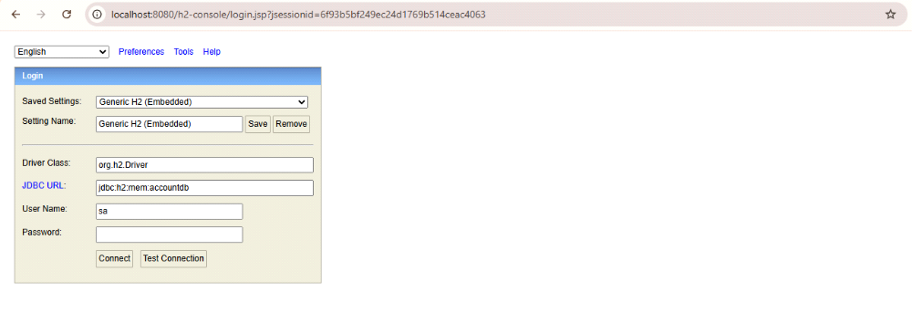

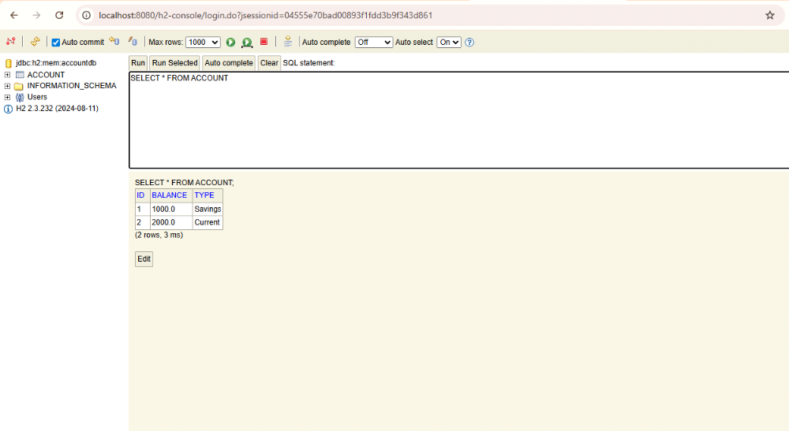

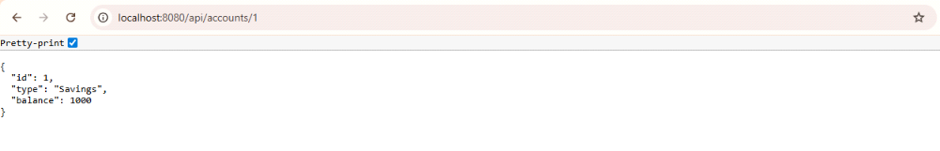

LOAN SERVICE

LoanServiceApplication.java

package com.example.loanservice;
import org.springframework.boot.CommandLineRunner;
import org.springframework.boot.SpringApplication;
import org.springframework.boot.autoconfigure.SpringBootApplication;
import org.springframework.context.annotation.Bean;
@SpringBootApplication
public class LoanServiceApplication {
public static void main(String[] args) {
SpringApplication.run(LoanServiceApplication.class, args);
}
@Bean
public CommandLineRunner loadData(LoanRepository repository) {
return args -> {
repository.save(new Loan("Home Loan", 500000.0));
repository.save(new Loan("Car Loan", 200000.0));
};
}
}

Loan.java

package com.example.loanservice;
import jakarta.persistence.*;
@Entity
public class Loan {
@Id
@GeneratedValue(strategy = GenerationType.IDENTITY)
private Long id;
private String type;
private Double amount;
public Loan() {}
public Loan(String type, Double amount) {
this.type = type;
this.amount = amount;
}
public Long getId() {
return id;
}
public String getType() {
return type;
}
public Double getAmount() {
return amount;
}
public void setId(Long id) {
this.id = id;
}
public void setType(String type) {
this.type = type;
}
public void setAmount(Double amount) {
this.amount = amount;
}
}

LoanRepository.java

package com.example.loanservice;
import org.springframework.data.jpa.repository.JpaRepository;
public interface LoanRepository extends JpaRepository<Loan, Long> {}

LoanController.java

package com.example.loanservice;
import org.springframework.web.bind.annotation.*;
import java.util.Optional;
@RestController
@RequestMapping("/api/loans")
public class LoanController {
private final LoanRepository repository;
public LoanController(LoanRepository repository) {
this.repository = repository;
}
@GetMapping("/{id}")
public Optional<Loan> getLoan(@PathVariable Long id) {
return repository.findById(id);
}
}

application.properties

spring.datasource.url=jdbc:h2:mem:loandb
spring.datasource.driverClassName=org.h2.Driver
spring.datasource.username=sa
spring.datasource.password=
spring.jpa.hibernate.ddl-auto=update
spring.jpa.show-sql=true
spring.h2.console.enabled=true

OUTPUT:
